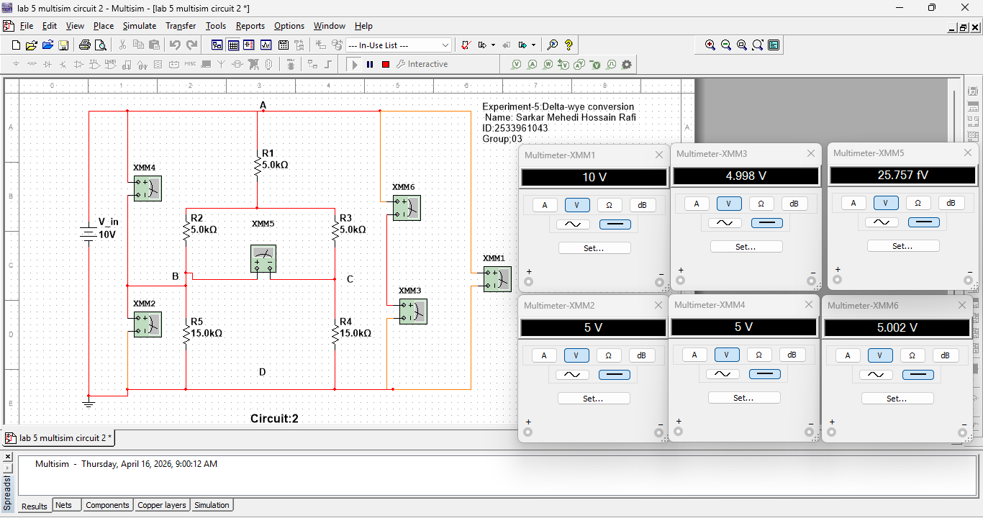
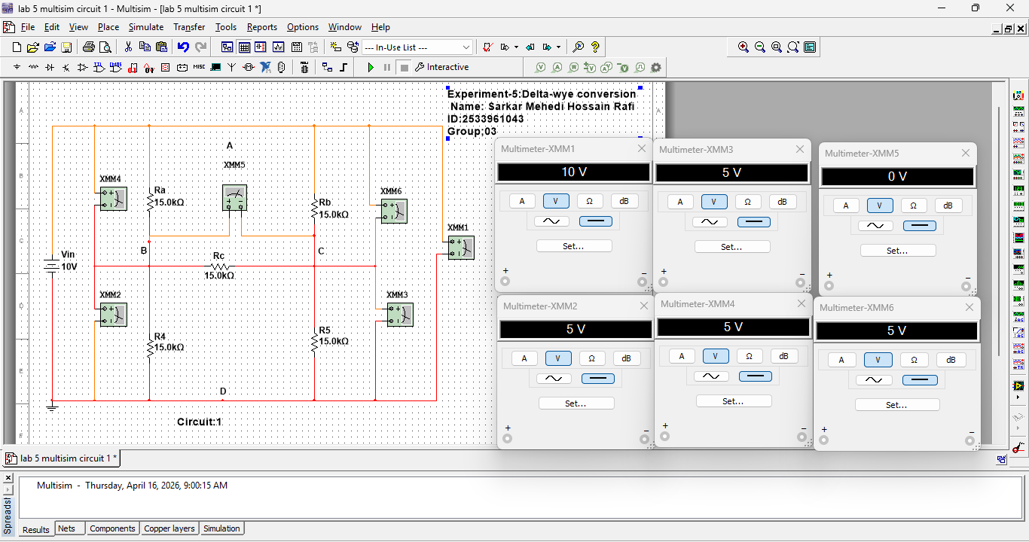
Name: Sarkar Mehedi Hossain Rafi
ID:2533961043 Group:3

